How to Book BSL tickets for John Rutter’s Christmas Celebration, Tuesday 6 December 2022.
Thank you for your interest in booking BSL tickets for this performance. Please follow the step by step instructions below to get the most appropriate seats.

- Click on this ‘Book BSL tickets’ link:
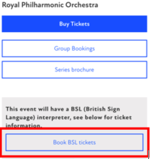
- On the Royal Albert Hall website, click ‘FIND TICKETS’
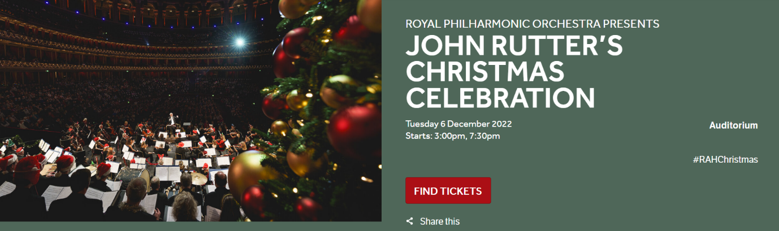
- Select the 3pm afternoon performance option
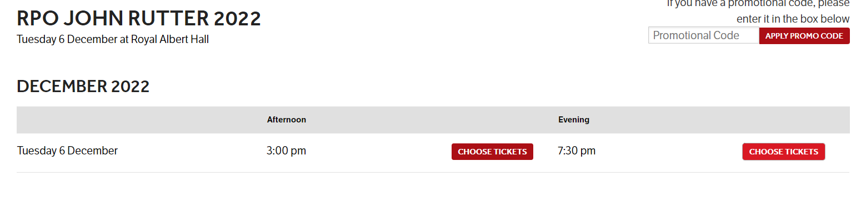

- The BSL interpreter will be on the left hand side of the stage, looking from the auditorium, so the area in Blocks G and H is the where we have situated BSL seats. Click anywhere on this picture to select those seats:
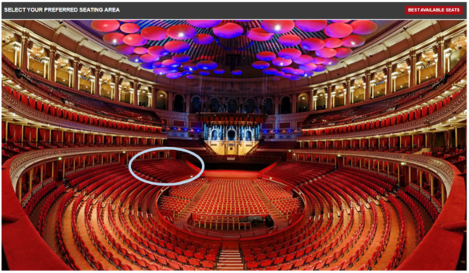
- Select one of the purple circles in this area to select a seat:
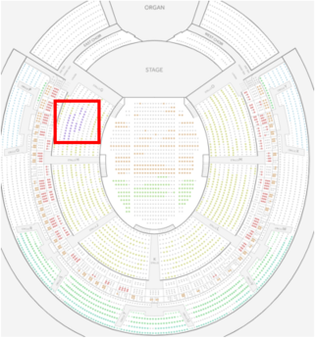
- In the window that pops up, select the appropriate ticket type for an adult, child or carer:
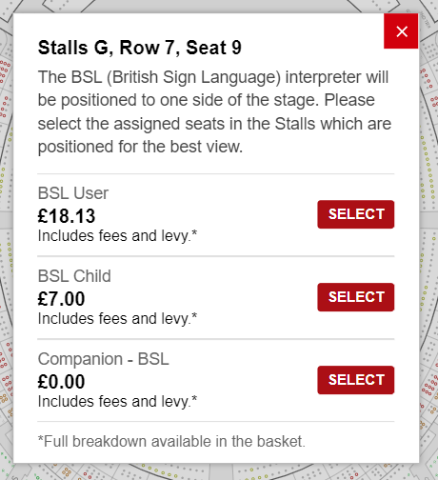
- Your selected seats will then show at the bottom of the screen. If you would like to change the ticket type of any of your tickets then you can change them using the drop down menu in that small window:
- Next press ‘Add to Basket’
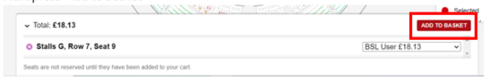
- Continue through to make a payment.

